**Vault Installation**

1. Install GPG: This is used for encrypting and signing data.

2. Download the Signing Key: This is used to verify the authenticity of the downloaded packages.

3. Verify the Key’s Fingerprint: This is used to ensure that the correct key has been downloaded.

4. Add the HashiCorp Repo: This is used to add the HashiCorp repository to your list of repositories.



5. Install Vault: This is used to install Vault.

sudo apt install vault

6. Start Vault: This is used to start the Vault server.

7. Enable AppRole Authentication: This is used to enable the AppRole authentication method in Vault.

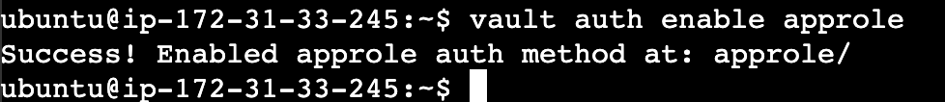

8. Create a Policy: This is used to create a policy that grants certain permissions.

9. Create an AppRole: This is used to create an AppRole with the specified policy.

10. Generate Role ID: This is used to retrieve the Role ID. Here the role id will be generated for terraform instead of my-approle

Generate Secret ID: This is used to generate a Secret ID. Here the secret -id will be generated for terraform instead of my-approle

